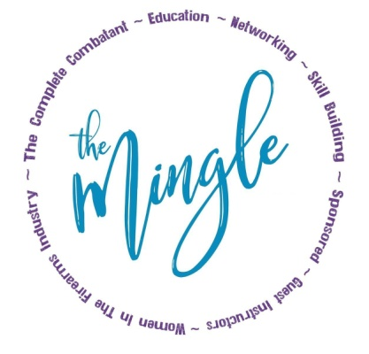
The Mingle 2021
“THE MINGLE” is an annual sponsored event for women in the firearms/self defense industry held in May of each year in North Metro Atlanta. This invite only weekend will be a HIGHLIGHT of our guest’s year! Saturday is 100% sponsored and we expect about 50 ladies. We will have a catered lunch from Hickory Prime BBQ , door prizes, a 2 hour block of live fire on the range and our 2021 guest speaker is Stephannie Weidner of Active Self Protection. Sunday is partially sponsored by HK and we will be ON THE RANGE with Brian Hill, Stephannie Weidner and Shelley Hill! We will be lending a hand in helping women in the firearms industry gain knowledge and meet MORE ladies in the biz. What a fantastic opportunity to be able to "pick the brains" of the ones that paved the path before us and meet ladies who offer NEW ideas. With the help of sponsors, The Complete Combatant will offer a place for women to meet "like minded" ladies and build relationships to support business, networking to expand contacts and to explore our own personal growth in business, tactics, self-defense, marksmanship, professions & MORE! These special ladies are all patriots that will influence, support, and fight for self defense rights! Please consider sponsoring!

The Complete Combatant is excited to announce that we are hosting our 5th Annual Mingle! I invite you to visit The Complete Combatant's website (www.thecompletecombatant.com) and click on Annual Events for past events and 2021 details! We have 1, 2 and/or 3 fundraisers each year that will benefit our featured charity Racheal’s Rest Programs (www.rachealsrest.org) through the nonprofit Broken Chains International.

Our next Mingle is on Sat. May 22nd and Sun. May 23rd, 2021 at our private range in Dahlonega and we would be honored to have you involved!

SPONSORSHIP OPPORTUNITIES: MONETARY DEADLINE IS APRIL 1ST, 2021.
- BRONZE SPONSORSHIP: $250
Social media thank you and your LOGO added to The Mingle 2021 website page
- SILVER SPONSORSHIP: $500
The ABOVE plus your business card added to our end of day gift bags and multiple shout outs and thank yous!
- GOLD SPONSORSHIP: $750
The ABOVE plus we will promote your business on ALL of The Complete Combatant's social media outlets once a month for 12 months and we will have your business cards on display for our students to grab during each public class for 1 year!
- PLATINUM SPONSORSHIP: $1000
The ABOVE plus we will hang your banner (you supply) at the event for the entire weekend!!!
- CORPORATE SPONSORSHIP: $1500
The ABOVE plus we invite one of your teammates (inside or outside of the fun community) to attend The Mingle 2021 Day 1 and/or Day 2 (depending on their firearms experience and safe gun handling) for FREE. Yes, ladies only!

DOOR PRIZES NEEDED: DOOR PRIZE DEADLINE IS APRIL 1ST, 2020
- We need DOOR PRIZES to raffle off for FREE or for profit. This is a fun way to help! DOOR PRIZES can be anything that is cool, new, needed or fun! If you donate a DOOR PRIZE you will receive a sponsorship level based on the gifts. THANK YOU!!

Monetary SPONSORSHIPS can be sent via check and made out to The Mingle. Please write The Mingle 2021 in the note/memo sections. Contact me (Shelley Hill) to get the address on where to send your sponsorship check and/or your DOOR PRIZE donations.

Shelley Hill: 404-936-6986 thecompletecombatant@gmail.com

