**THE COMPLETE COMBATANT’S 4 SCORED DRILLS**

The following courses of fire challenge the armed citizen to perform the most common technical skills from a concealed draw. A well-designed interlocking curriculum provides a platform for building and evaluating core skills, efficiency, effectiveness, and mental fortitude.

I use martial art belt ranks as the basis for the patch system when shooting the CORE 4. I have taught and developed this curriculum for four decades, and I have a deep understanding of the developmental process of athletes.

**The Bullseye** course checks shot calling, dot tracking, and accuracy using an extended prep and press to work on hand stopping (95-5, 90-10, 80-20) vision cues (flash, floating, focused), and trigger speed (quickly, carefully, precisely).

**The Trifecta** is a simple test to measure the shooter’s ability to adjust hand, trigger, and vision speed relative to the target size with maximum efficiency.

**Mixed Six** is a basic course of fire with par times to teach different hand position that armed citizen may need to employ.

**The Core Four** establishes a baseline for current level of skill in common shooting drills. It also provides a percentage rating for the belt test patch.

**Bullseye Drill**

**Target**: B-8 repair center

**Distance**: 5, 10, 15, 20, 25 yards

**Untimed**

**Directions**: Extended prep and press. Fire 1, 2, then 3 shots from the press out with no time limits at each distance above.

Scoring: 10,9,8,7,0 points

**Rounds:** 30 rounds total.

Maximum possible score = 300 points. Goal 270 and above (90%)

**The Trifecta Drill**

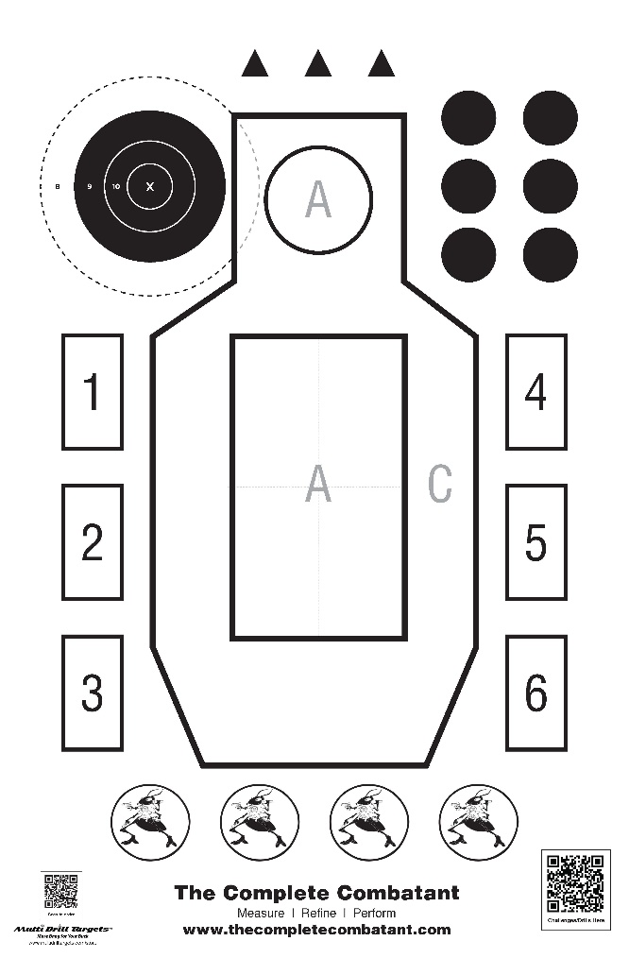

**Target**: The Complete Combatant target. Use inner body “A” (full rectangle acceptable). If more advanced, you can use the bullseye on shoulder (full 8 ring acceptable). head circle, one of the 2-inch black circles on shoulder)

**Distance**: 3 yards.

**Timed**

**Directions**: Draw and fire one shot on the timer individually to each of the targets mentioned above.

Add the three times together for the score. Line breaks count. Three misses total are allowed (1 ea., 2/1 mix, or 3 on one target)

**Rounds:** 3 rounds total.

**Measuring Performance on The Trifecta Drill:**

**Master:** 3 seconds or less

“A” Body .8. Head 1.0. Black circle 1.2

**Expert:** 3.1 - 4 seconds

“A” Body 1.0. Head 1.25. Black circle 1.5

**Advanced:** 4.1 – 5 seconds

“A” Body 1.25. Head 1.50. Black circle 1.75

**Intermediate:** 5.1 – 6 seconds

“A” Body 1.50. Head 1.75. Black circle 2.00

**Mixed Six**

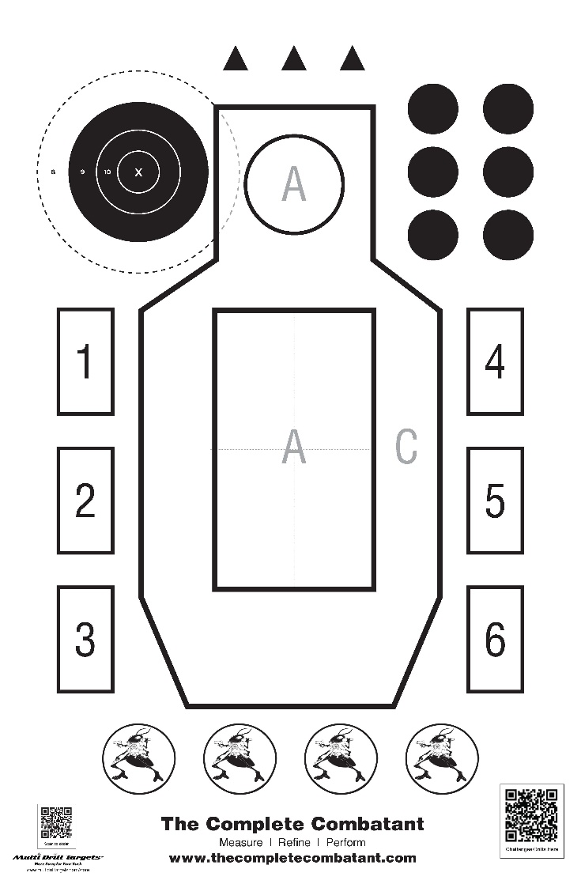

**Target**: The Complete Combatant target. Bullseye/B8 on shoulder

**Distance**: 7 yards

**Par time.**

**Directions**: All shots to the B-8 except for 1 head shot

**Needs**: 15 rounds. 2 magazines, or 3, if single stack. Simulated phone/ammo tray.

1- Hands up (fence/frames) draw and fire 2 in 3 seconds

2-Primary hand only draw and fire 2 in 5 seconds

3- Support hand on the phone by the ear, draw and fire 2 in 3 seconds

4- Failure to neutralize. Draw and fire 2 to the body and 1 to the ocular cavity in 4 seconds.

5- Low ready, issue verbal command, on the start signal fire 2 in 3 seconds

6- Start with 2 rounds in the gun. Draw and fire 2, reload fire 2 more in 9 seconds.

Maximum score=150. Goal: 90% and above (135)

B-8 scoring: 10,9,8,7,0 points. Head shot: 10 points in the ocular box, 9 if in the head.

**Core Four**

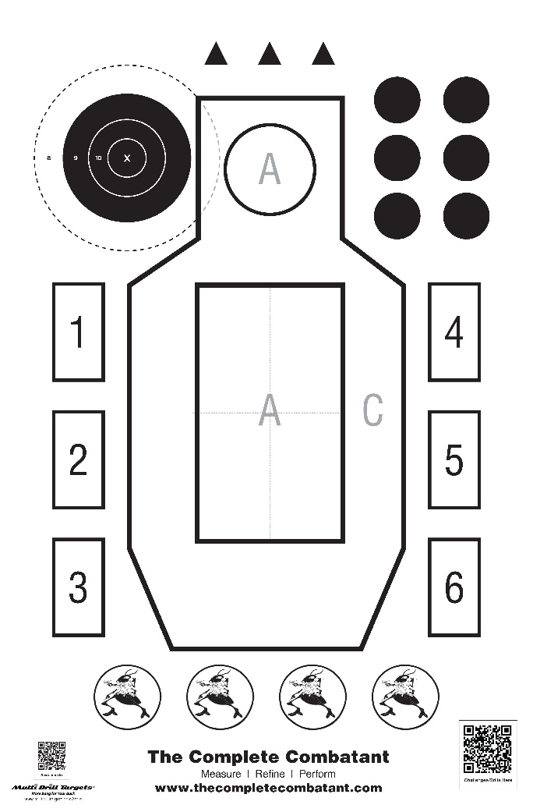

**Target**: The Complete Combatant target. IDPA or USPSA target will also work.

**Distance**: 7 yards

**Hit Factor** (points/seconds x multiplier)

**Directions**:

**Needs**: 15 rounds, 2 magazines

1-Hands Up (fence/frames). Draw and fire 2 rounds to the body (Goal: 1.25 and under)

2-Bill Drill. Draw and fire 6 rounds to the body. (Goal: 2.00 and under)

3-Failure to Neutralize. Draw and fire 2 to the body & 1 to the head. Goal: 1.5 and under)

4-Draw and fire 2 to the body perform a speed reload and fire 2 to the body (Goal: 3.25 seconds)

**Scoring**:

Shooters Qualify for:

Black Ant Rank 90% and ABOVE

Brown Ant Rank 80% - 89.99%

Purple Ant Rank 70% - 79.99%

Blue Ant Rank 60% - 69.99%