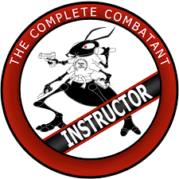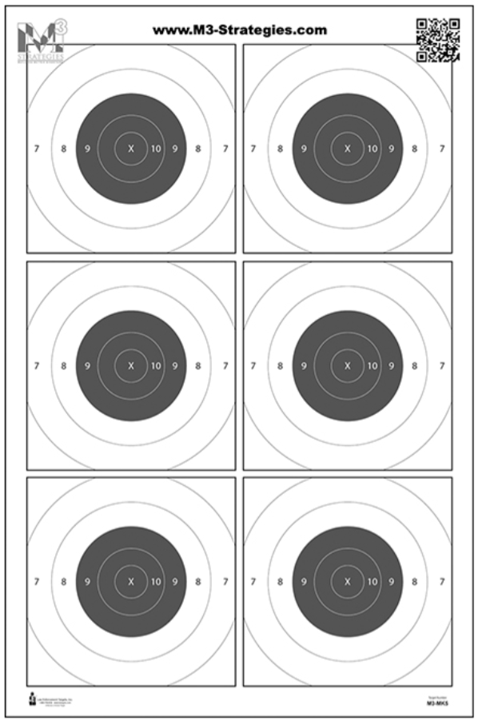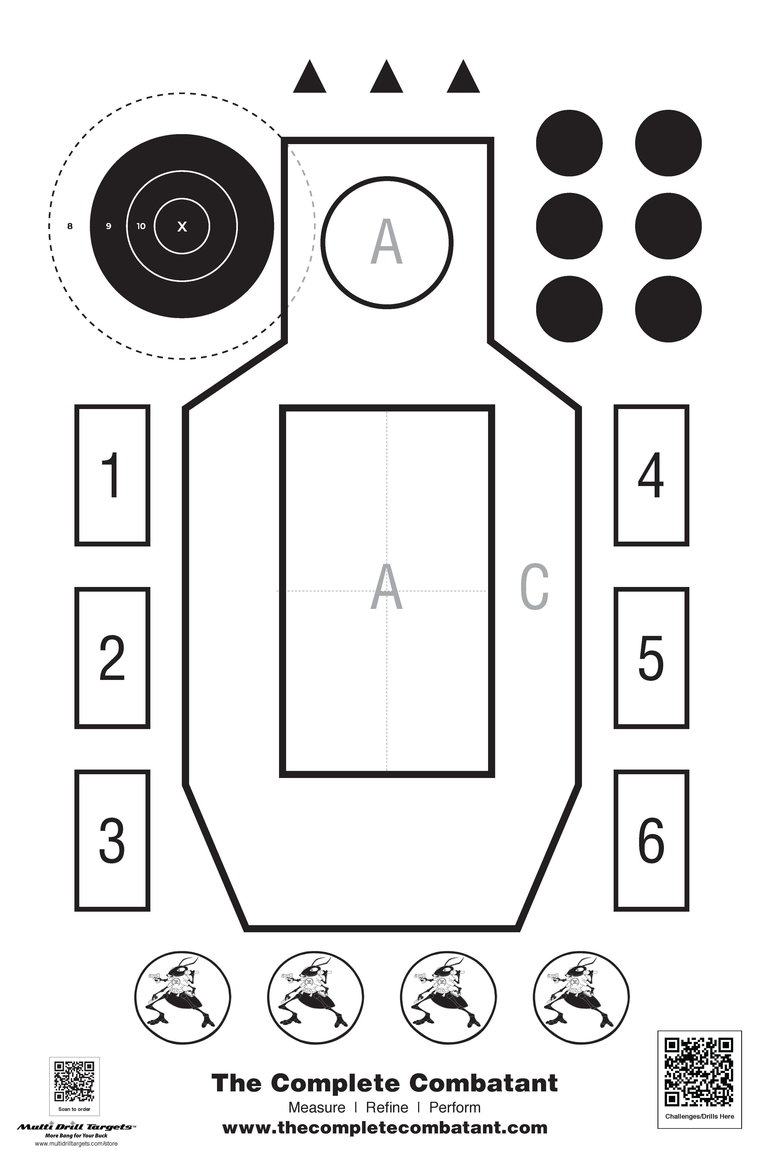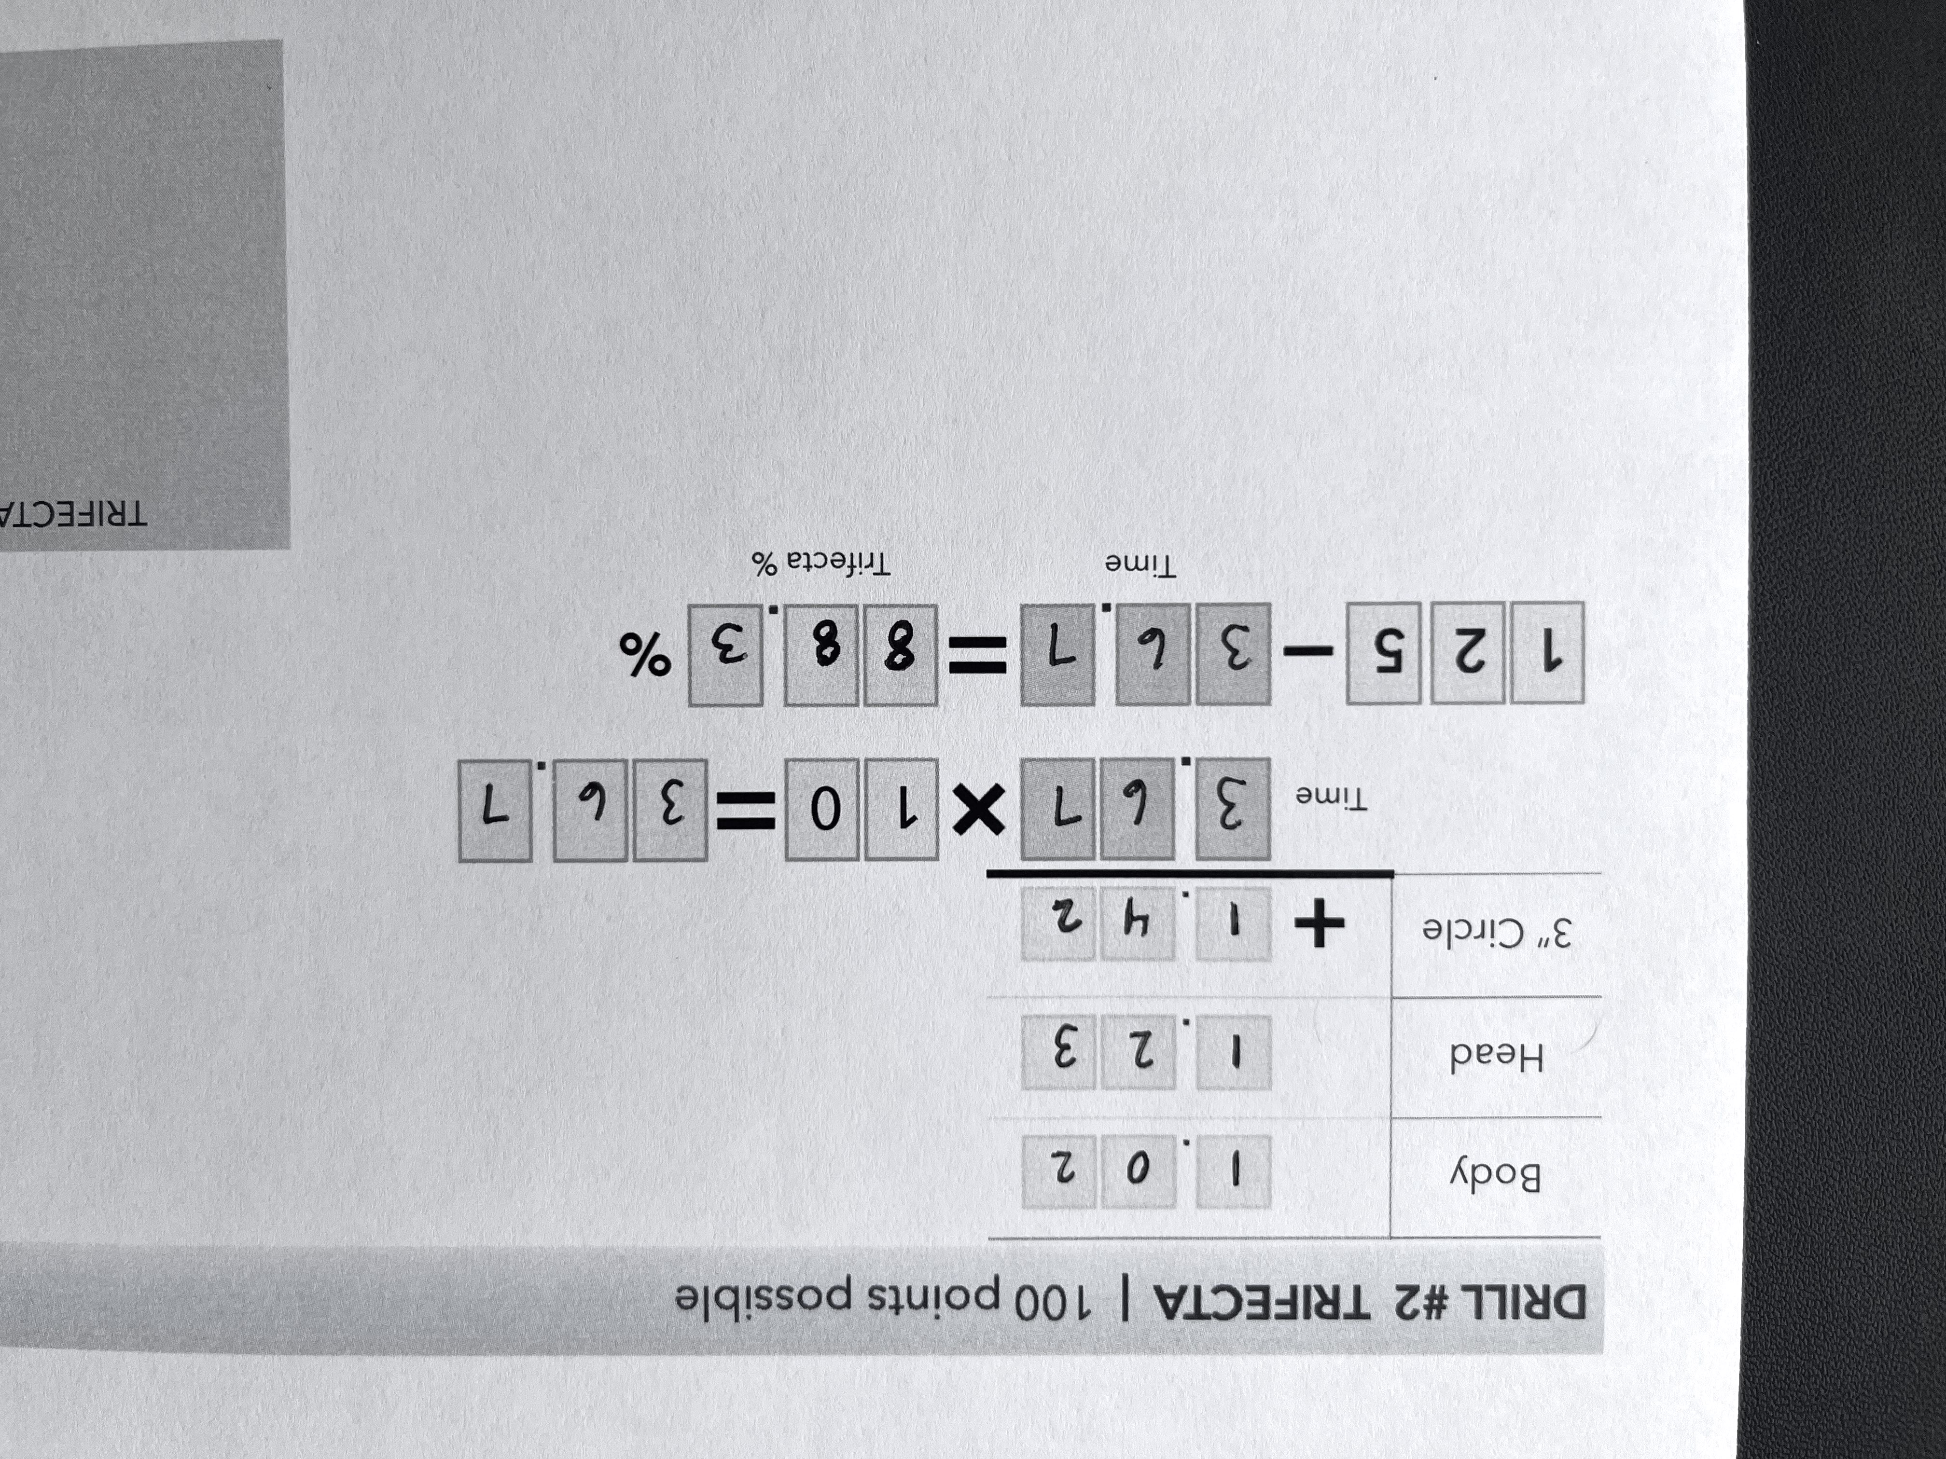

YOUR NAME:

__________________________________

DRILL #2 TRIFECTA | 100 points possible

|  |  |
| --- | --- |
| Bullseye  Score |  |
| Trifecta Score |  |
| Mixed 6  Score |  |
| Core 4  Score |  |
| **Total Score** |  |

|  |  |
| --- | --- |
| Body |  |
| Head |  |
| 3” Circle |  |

.

.

.

Scoring

X & 10 ring minus 0 pts

9 ring minus 1 pt

8 ring minus 2 pts

7 ring minus 3 pts

outside 7 ring minus 10 pts

DRILL #1 BULLSEYE | 300 points possible

|  |  |
| --- | --- |
| Total Possible |  |
| Total Points Down |  |

3

0

0

Your Bullseye Score

TRIFECTA SCORING **EXAMPLE**

Score Sheet for Day #________

.

Trifecta %

%

.

1

2

5

Time

Time

.

.

1

0



DRILL #4 CORE 4 | 75 points possible

Total points divided by total time multiplied by 11 equals your score as a percentage.

|  |  |
| --- | --- |
| Draw & fire 2 to body |  |
| Draw & fire 6 to body |  |
| Draw & fire 2 to body  1 to head |  |
| Draw & fire 2 to body, reload, 2 to body |  |

.

.

.

.

.

Time

Add 1 second **if not** shooting from concealment or duty/retention holster

.

*1*

*0*

*0*

.

Total Time

Points

**÷**

.

Total Time

DRILL #3 MIXED 6 | 150 points possible

|  |  |
| --- | --- |
| Stage | *Par Time* |
| Draw & fire 2 to X ring | *3.00* |
| With dominant hand only, draw & fire 2 to X ring | *5.00* |
| Draw & fire 2 to body  & 1 to head | *4.00* |
| Drop item in support hand, draw & fire 2 to X ring | *3.00* |
| From low ready, issue verbal command, upon beep  fire 2 to body | *4.00* |
| Draw & fire 2, reload, fire 2 | *9.00* |

|  |  |
| --- | --- |
| Total Possible |  |
| Total Points Down |  |

1

0

5

Your Mixed 6 Score

Your Core 4

Score

%

**×**

1

1